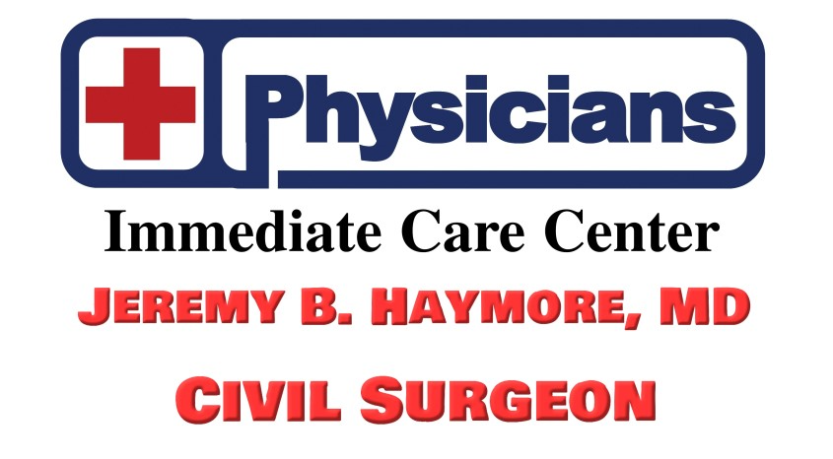
1252 Bennett Ave Suite A
Burley ID 83318
Phone: (208) 647-0656 Fax: (208) 647-0659
Authorization for Disclosure of Medical Records Information

Patient Name: _______________________________________________DOB:______________
Patient Address: ________________________________________________________________
Street City/Town State Zip code
Are you working with an attorney or organization you want us to share information with?
I Authorize:
Release information From: (send to us)
(Name , Address, Phone and Fax)
_________________________________________________________________________________________________________________________________________________________________________________________________________________________________________________________________________________

Release information to: (send to them)
(Name, address, Phone and Fax)
___________________________________
_________________________________________________________________________________________________________________________________________________________________________________________________________________________________________________________________________________

For the Purpose of: ☐ Treatment ☐Personal ☐Insurance ☐Legal ☐Other:_________
Requested Information: __Needed Information for completion of I-693__________________
Covering the period from: ___/___/___ To: ___/___/___
I understand that this Authorization will remain in effect for 12 months or I provide written notice of revocation to Physicians Immediate Care Center and its affiliates to use and or disclose health information for the purpose noted above. I understand that once such information has been disclosed to the intended, that PICC cannot guarantee that the recipient will not re-disclose my health information to a third party. The third party may not be required to abide by this authorization or applicable federal and state law governing to use the disclosure of my health information.
I am aware that the record to be disclosed pursuant to this Authorization may contain the following information subject
matter and I am authorizing the release of such highly sensitive information:
-Alcohol/drug use, abuse and/or treatment
-Treatment for mental illness and/or social services communication
-History of venereal or other communicable disease(s)
- Treatment or testing for HIV/AIDS
Patient/Guardian Name (print):_______________________________________________________

Patient/Guardian Name (Signature):________________________________________Date ___________

Relation to Patient:__________________________________ Phone Number: (____)_______-________

